## LIBRARY MANAGEMENT SYSTEM

## A

## PROJECT REPORT

## Submitted in partial fulfilment of the requirements

## for the degree of

## BACHELOR OF TECHNOLOGY

## in

## COMPUTER SCIENCE & ENGINEERING

## By

## Aryan Chakraborty

## 0187CS171034

## Under the guidance of

## PROF. RAHUL DUBEY

## (Assistant Professor)

## SISTec

## JULY-2019

## Department of COMPUTER SCIENCE & ENGINEERING

## Sagar Institute of Science & Technology (SISTec)

## Bhopal (M.P.)

## An ISO 9001:2008 Certified Institution

## Approved by AICTE, New Delhi & Govt. of M.P.

## Affiliated to Rajiv Gandhi Proudyogiki Vishwavidyalaya, Bhopal (M.P.)

**Sagar Institute of Science & Technology (SISTec), Bhopal**

## Department of COMPUTER SCIENCE & ENGINEERING

**Bhopal (M.P.)**



**July-2019**

# CERTIFICATE

I hereby certify that the work which is being presented in the B.E. Project Report entitled **Library Management System,** in partial fulfillment of the requirements for the award of the degree of **Bachelor of Engineering** in **Computer Science & Engineering** and submitted to the Department of Computer Science & Engineering, Sagar Institute of Science & Technology (SISTec)**,** Bhopal (M.P.) is an authentic record of my own work carried out during the period from 01-07-2019 to 13-07-2019 under the supervision of Prof**. Rahul Dubey (assistant prof.).**

The content presented in this project has not been submitted by me for the award of any other degree elsewhere.

Submitted By -

Aryan Chakraborty

0187cs171034

This is to certify that the above statement made by the candidate is correct to the best of my knowledge.

**Date:**

**Principal**

**HOD**

**Project Supervisor**

**ACKNOWLEDGMENT**

It gives us immense pleasure to express our deepest sense of gratitude and sincere thanks to our highly respected guide **Dr. Rajeev Kumar Gupta**, Associate Professor and our Project Coordinator **Prof. Rahul Dubey**, Department of Computer Science and Engineering, Sagar Institute of Science & Technology Gandhi Nagar Bhopal, for their valuable guidance, encouragement and help for completing this work. Their useful suggestions for this whole work and co-operative behavior are sincerely acknowledged.

We would like to express gratitude to **Dr. Keshavendra Choudhary**, Principal, Sagar Institute of Science & Technology, Gandhi Nagar, Bhopal, and **Dr. Swati Saxena**, Vice Principal, Sagar Institute of Science & Technology, Gandhi Nagar, Bhopal for giving us an opportunity to undertake this project.

We also wish to express our gratitude to **Prof. Ujjwal Nigam**, Head, Department of Computer Science and Engineering/IT, for his kind-hearted support.

In the end, we would like to express our sincere thanks to our family and all the people who helped us directly or indirectly during this project work.

Aryan Chakraborty

0187CS171034

|  |  |
| --- | --- |
|  |  |
|  |  |
|  |
|  |
|  |  |
|  |  |

1. **Introduction: -**

The project titled Library Management System is Library Management software for monitoring and controlling the transactions in a library. The project “Library Management System” is developed in python, which mainly focuses on basic operations in a library like adding new books, and updating new information, searching books and members and return books.

This project of “**LIBRARY MANAGEMENT SYSTEM**” gives us the complete information about the library. We can enter the record of new books and retrieve the details of books available in the library. We can issue the books to the students and maintain their records and can also check how many books are issued and stock available in the library. In this project we can maintain the late fine of students who returns issued books after the due date.

Throughout the project the focus has been on presenting information and comments in an easy and intelligible manner. The project is very useful for those who want to know about Library Management System.

***Problem Statement: -***

Make a library management system using python and file handling for storing and retrieving data and following concepts of Object-Oriented Programming.

Which can perform the basic operation like issue/reissue books, view details, search book, add student, add faculties etc. And it should have an admin who controls and manage all the data and have all rights.

1. **Software Requirements Specification: -**

**2.1>Purpose: -**

This is the Software Requirements Specification (SRS) for the Library Management System. The purpose of this document is to convey information about the application's requirements, both functional and nonfunctional, to the reader. This document provides:

A description of the environment in which the application is expected to operate.

A definition of the application's capabilities.

A specification of the application's functional and nonfunctional requirements. The document is intended to serve several groups of audiences:

**2.2>Scope of Project: -**

The purpose of this software development project is to create a new application called: Library Management System, the client for this project wishes to enter the PC-based console environment. The Library Management System will be console based, allowing library users to search for books, seminars and library staff members (ADMIN) to manage the book inventory and user file. The application will provide the following capabilities:

Library staff will be able to manage library user accounts including remove, change, and add.

Library staff will be able to manage the book inventory file including remove, change, and add.

The application will provide search function on books based on book no, subject, title, or author.

The project's client has determined that this application will provide the following benefits:

* Provide additional flexibility and convenience to the library users.
* Provide better reliability and security of the library information.
* Provide a more productive environment for the library staff member.
* Reduce the cost of the library operations. The availability of information at any time in any place.

**2.3> User Characteristics: -**

The three types of user for the Library Management System are:

* Librarian (Admin)
* User (Students).
* User (Faculty)

The following table describe general users’ characteristics that will affect the functionality of the software product.

**2.4> Requirements: -**

**2.4.1> Functional Requirements: -**

* **Administrative**

Administrative interfaces will assist Library Staff in building/maintaining collections and controlling access to them. Because of the complexity of the data model, Library Staff will need to be able to edit records simultaneously and create links between them. Administrative MUST be able to have records open for editing Administrator MUST be able to create links (references) between records without needing to type in record identifiers.

Additionally, data represented in the administrative interface may be in a differentiate than that stored in the repository.

* **Library user account manage system**

The system shall display the user account information including user ID, last and first name, and user position, privilege.

The system shall use a graphic user interface which allows librarians to choose actions including removing, changing and adding user account and account information.

* **Search book record**

The system shall display a list of books which are matching the search criteria sorted by book titles including:

* + - The ISBN
    - The title
* **Data Entry**

The data entry requirements are concerned with how data is entered and validated.

* The system shall allow a user to enter his/her data via a keyboard.
* The system shall allow a user to enter his/her data via choose an item via a mouse.
* The system shall allow the user to enter the Registration number and ISBN by typing.
* The system shall allow the user to add or change information in an account including: last name, first name, user ID, user position, user privilege.
* The system shall allow the user to delete an entire account.
* **Search book record**

The system shall allow the user typing in search criteria including book title, ISBN. The system will show the details including book no., title and number of copies available in library.

* **Update book data**

The system shall allow the user to add or change the record information including

* + - The title
    - The book no

**3.> User case Diagram: -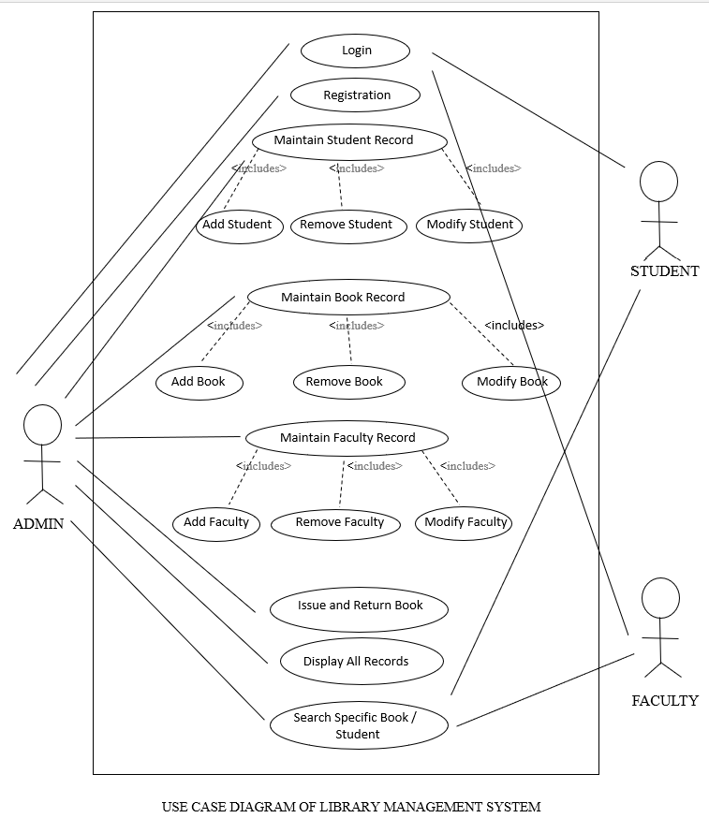 4.> Summary: -**

Library management system is a project which aims in developing a computerized system to maintain all the daily work of library. This project has many features which are generally not available in the normal library management system like facility of user login.it also has a facility of admin login through which admin can monitor the whole system. It also has the facility that the student after login into their account can issue the book they want, can return the book into the library and can search for book in the library. Same can be done by the teacher after logging into their account .The Librarian after logging into his account i.e., admin account can see the student record , teacher record and the books available in the library  
Overall this project is being developed to help the student and the staff in the best possible way and also to reduce the human effort.